Solve time always 00:00 1970
1.Connect the phone and the clock to the same wifi, then open the browser on the phone and enter the IP address displayed by the clock (it will be displayed when the clock is turned on). You can set the clock there.
Find Sync phone or PC time and turn on this switch. This will solve the problem.
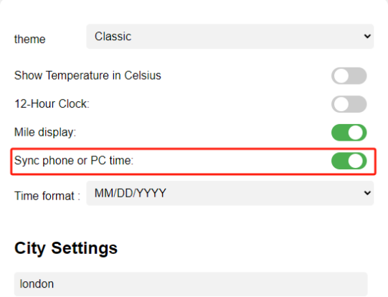

If it doesn't work, proceed to the next step:
Search on Google: What are the NTP servers near your city?
In our settings page, find the setting option of our NTP server and fill in the ntp server recommended by Google.For example: pool.ntp.org
then quickly click the number below 10 times, and then click Save.
